

Policy Target Regime-Switching Persistence Reference Country: Japan

Author: Elia Landini
Student ID: 12310239
Course: EESM2-Financial Economics
Class: Monetary & Financial Economics
Supervisor: Jean-Bernard Chatelain

Reference Repository:
https://github.com/EliaLand/Policy_Target_RegimeSwitchingPersistence

- Summary
In this work we provide a replication study of Lofaro and Di Bucchianico (2025), which investigates the impact of monetary policy on functional income distribution using a panel vector

- Chapter 1 - Dataset, Univariate & Bivariate Descriptive Statistics After Transformations

2.1 In your data set, which are the variables which are varying with respect to two indices (or more) if you consider inflows and outflows from one individual or country to another individual or countries? Which are the variables which are varying only with respect to time? Which are the variables which are varying only with respect to individuals?
In this work we provide a replication study of Lofaro and Di Bucchianico (2025), which investigates the impact of monetary policy on functional income distribution using a pan

Figure 1.1.7 – Variables Evolution Overtime (Part 1)
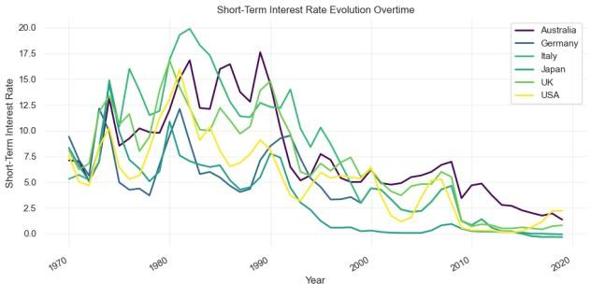
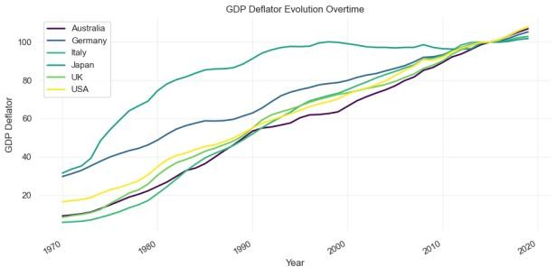
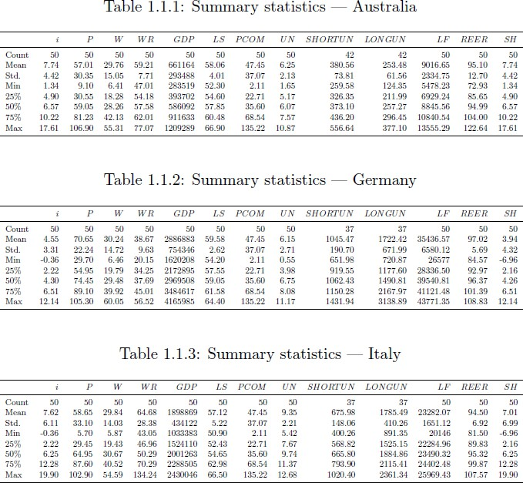

- Bibliography
Lofaro, A., & Di Bucchianico, S. (2025). Impact of monetary policy on functional income distribution: A panel vector autoregressive analysis. Economic Modelling, 107227
Wansbeek, T

